GARAGE MANAGEMENT SYSTEM

(DEVOLOPER)

**Mentor : SRI L.LAKSHMI NARAYANA**

**TEAM ID : LTVIP2024TMID11767**

**TEAM LEADER** : SURAPAREDDY TRIMURTHULU

**HALL TICKET NUMBER** : 213887102068

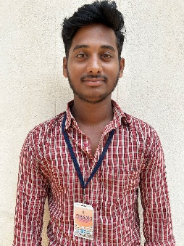**Mail Id :** [trimurthulusurapareddy9@gmail.com](mailto:trimurthulusurapareddy9@gmail.com)

**Team Member** : MYNAM SATYA RANGABABU

**Hall Ticket Number** : 213887102052

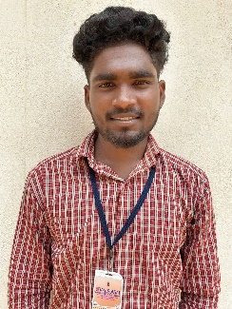**Mail Id** : [mynamrangababu@gmail.com](mailto:mynamrangababu@gmail.com)

**Team Member** : PATNALA ABHI SRI RAM TARUN TEJ

**Hall Ticket Number** : 213887102058

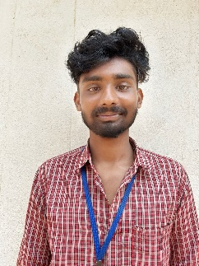Mail Id : patnalaabhiram@gmailcom

**Team member** : CHILUKURI JAYA UDAY MANIKANTA

**Hall Ticket Number : 213887102017**

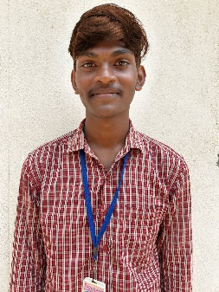**Mail Id :** [manikantaudhay@gmail.com](mailto:manikantaudhay@gmail.com)

**Team Member : SATTINEEDI JNANA VENKATA SAI**

**HALL TICKET NUMBER : 213887137109**

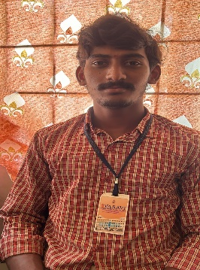

**Mail Id : janusattineedi@gmail.com**

**Garage Management System**

The Garage Management System is a valuable tool for automotive repair facilities, helping them deliver top-notch service, increase operational efficiency, and build lasting customer relationships. With its user-friendly interface and powerful features, GMS empowers garages to thrive in a competitive market while ensuring a seamless and satisfying experience for both customers and staff.

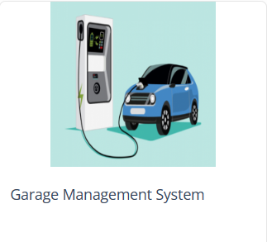

**TEAM PROJECT**

Salesforce account details

**User Name :** [**thimmu@srivasavi.com**](mailto:thimmu@srivasavi.com)

**Password : Suresh123**

**TSK -180056**

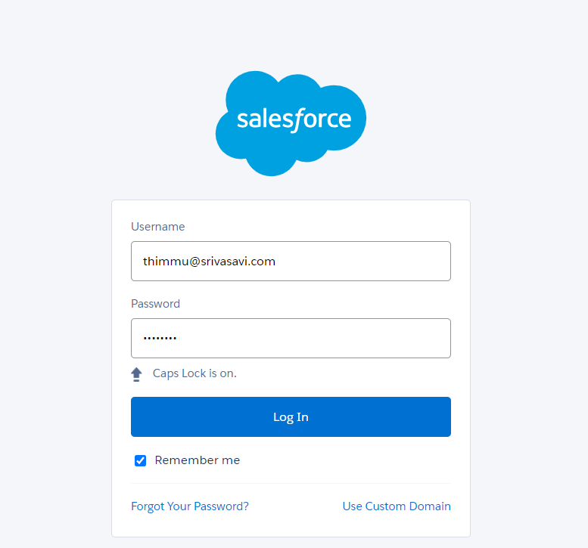

**TSK-180057**

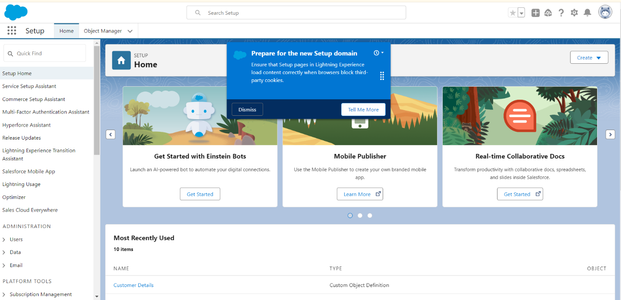

**TSK-180058**

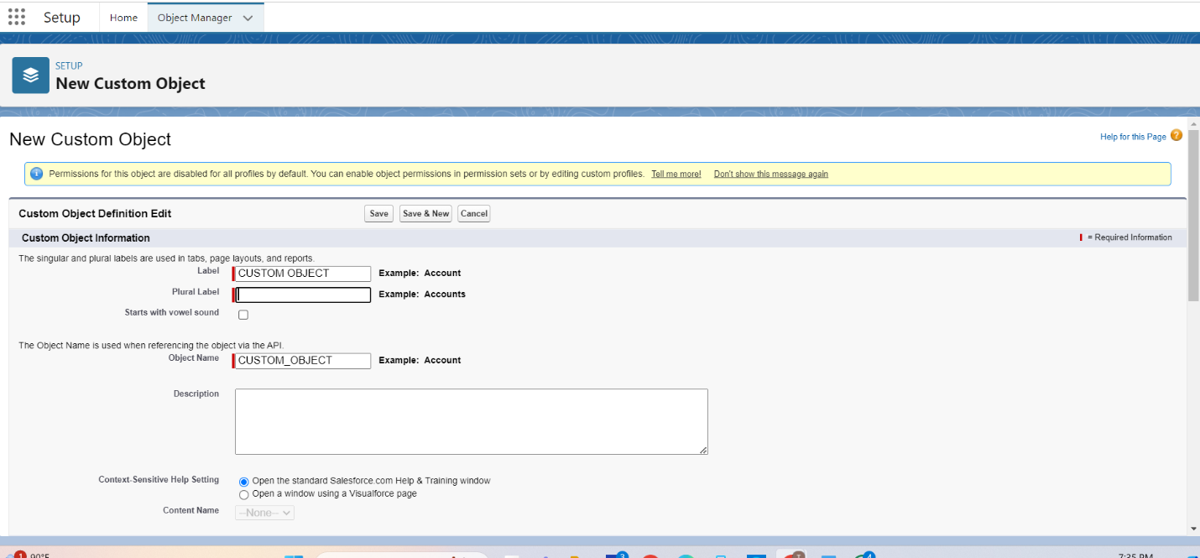

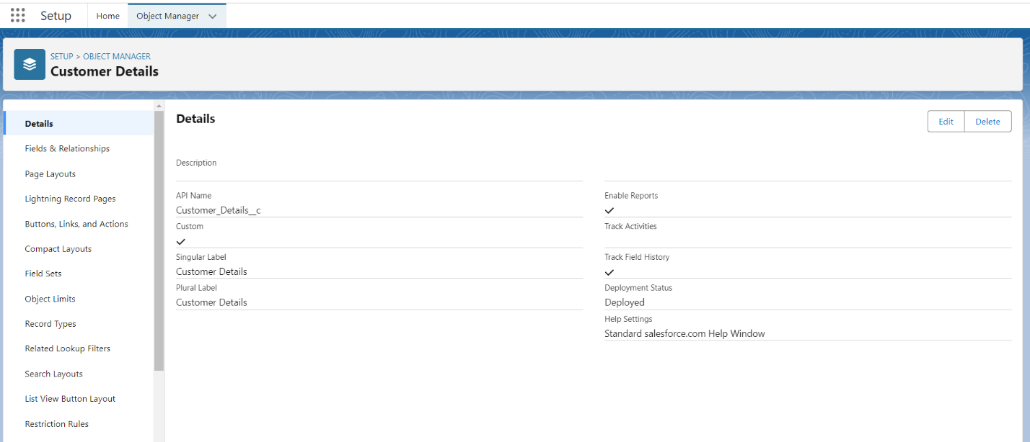

**TSK180059**

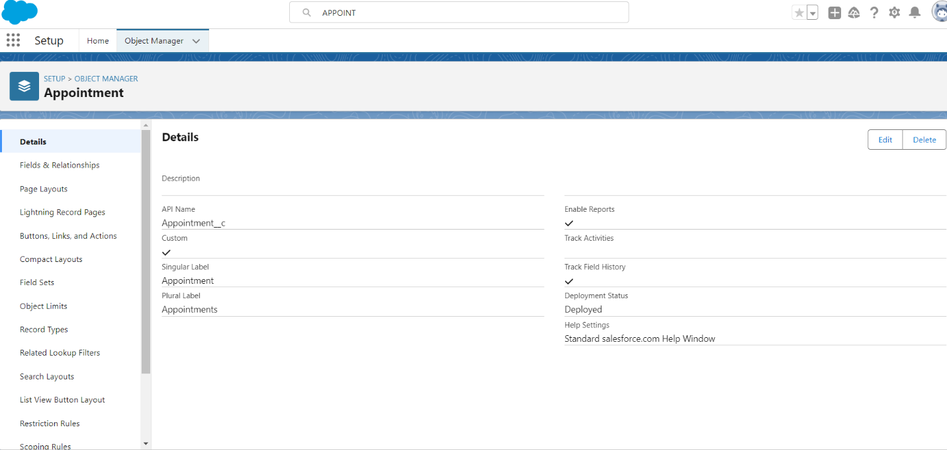

**TSK-180060**

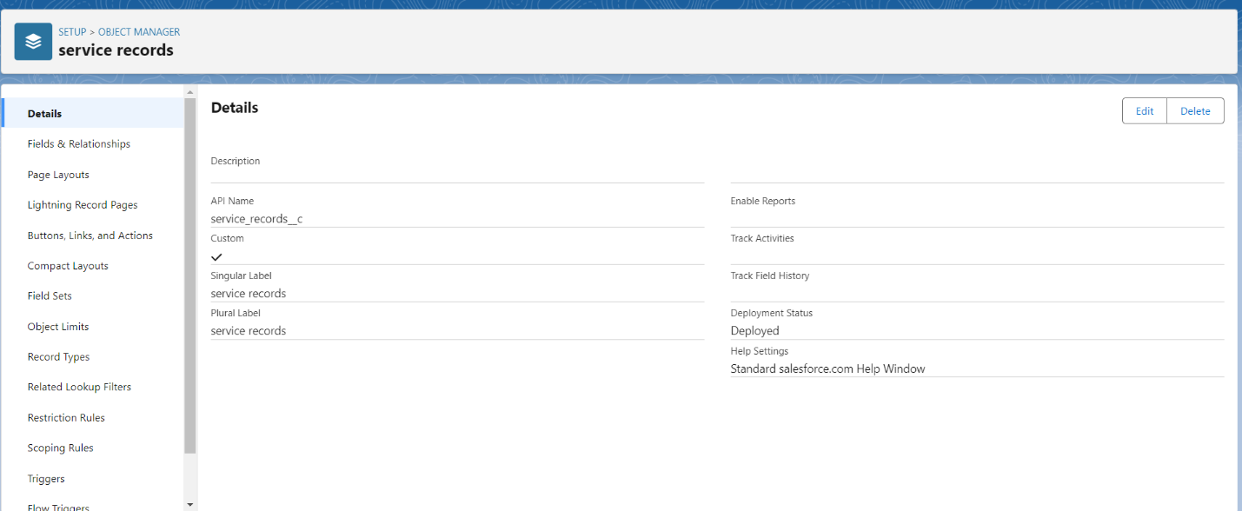

**TSK-180061**

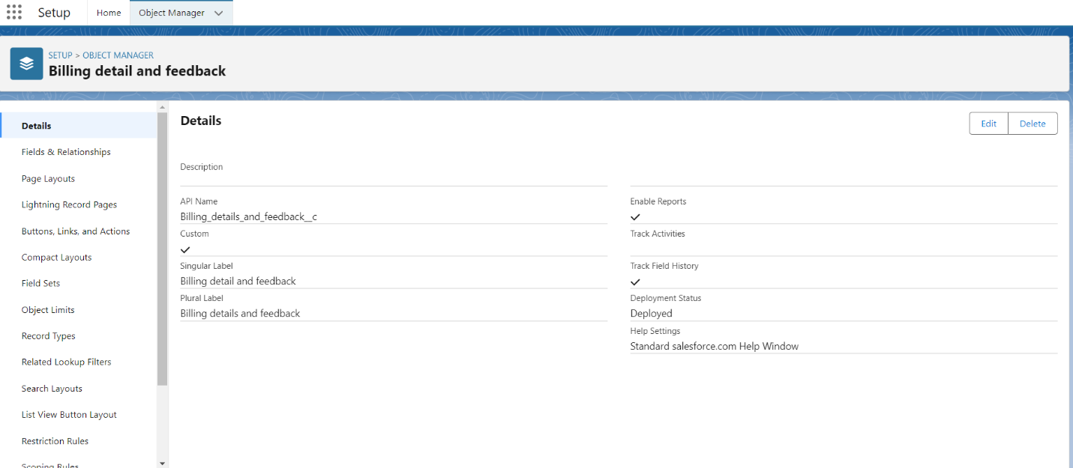



**TSK-180062**

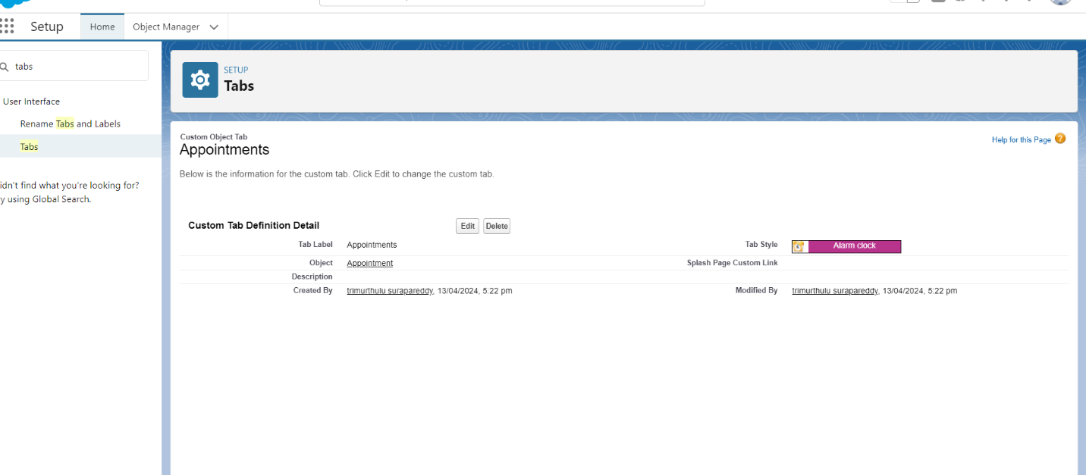

**TSK-180063**

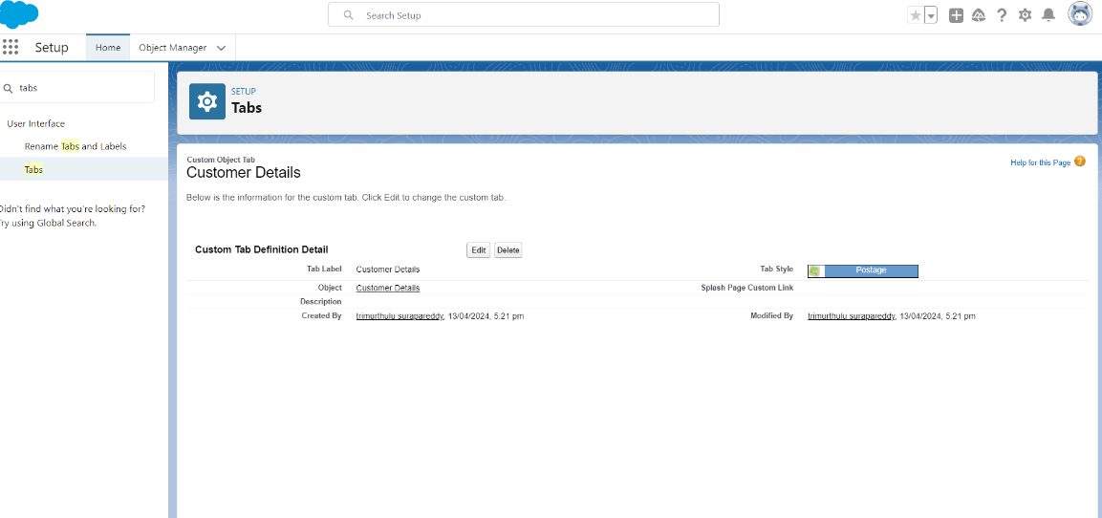

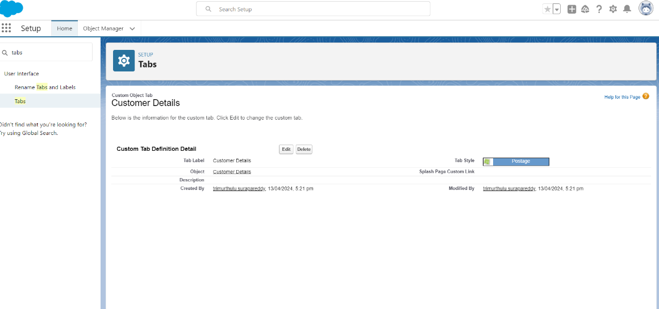

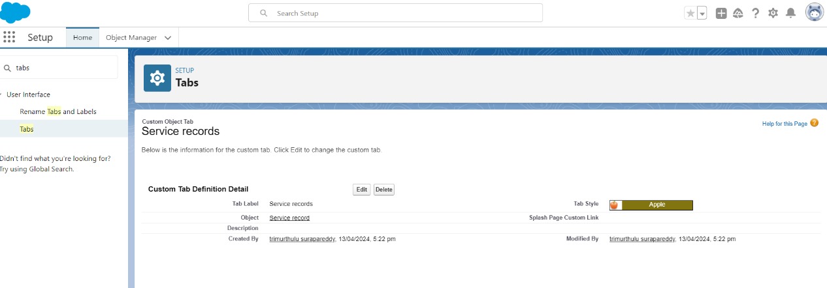

**TSK-180064**

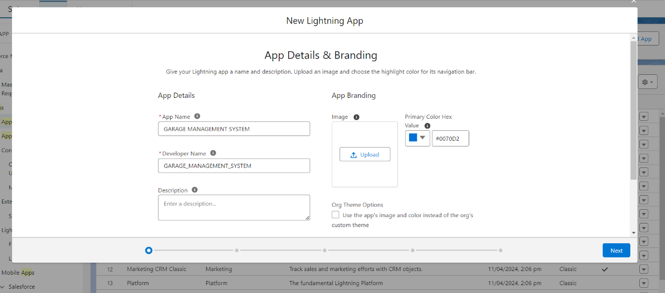

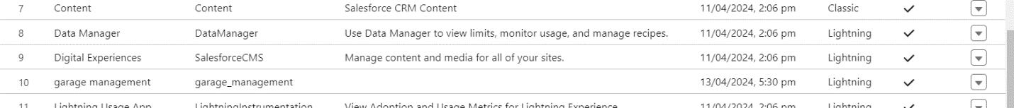

**TSK-180065**

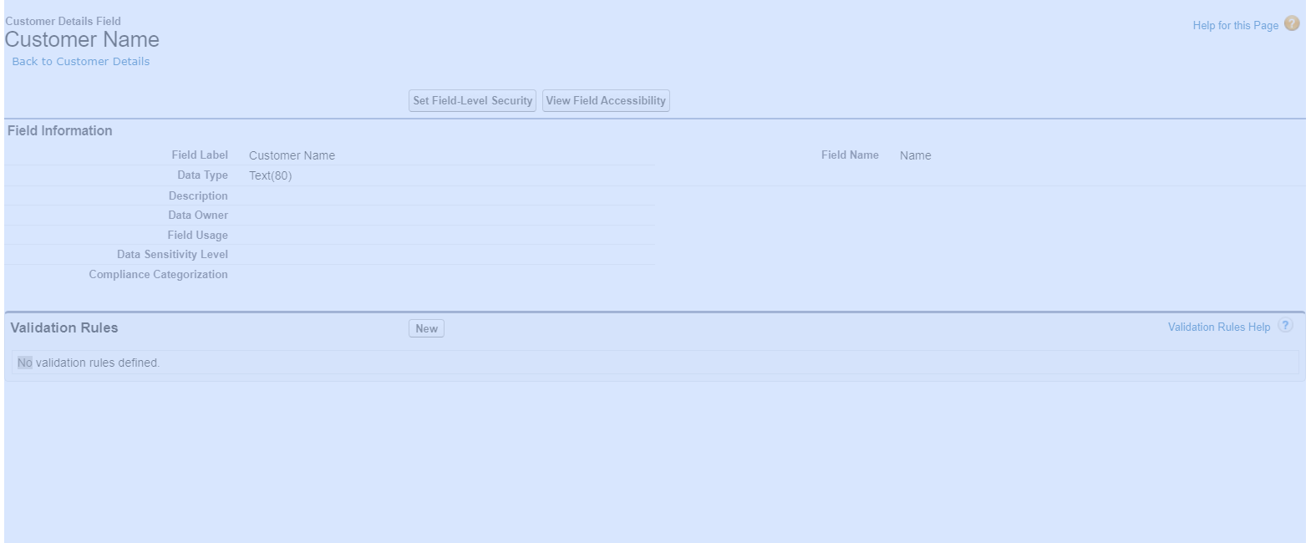

**TSK-180066**

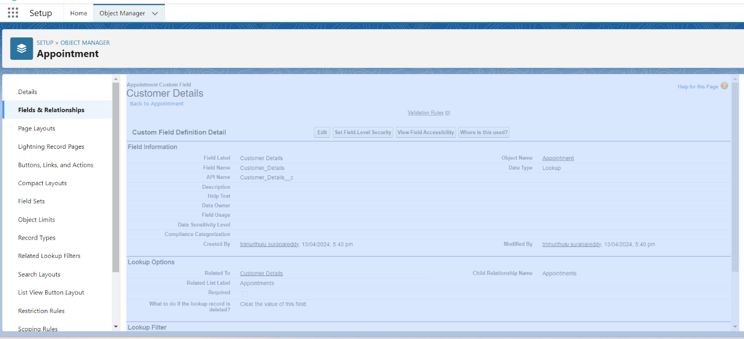

**TSK-180067**

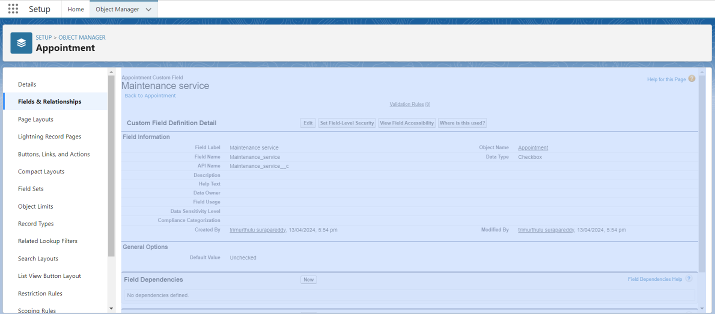

**TSK-180068**

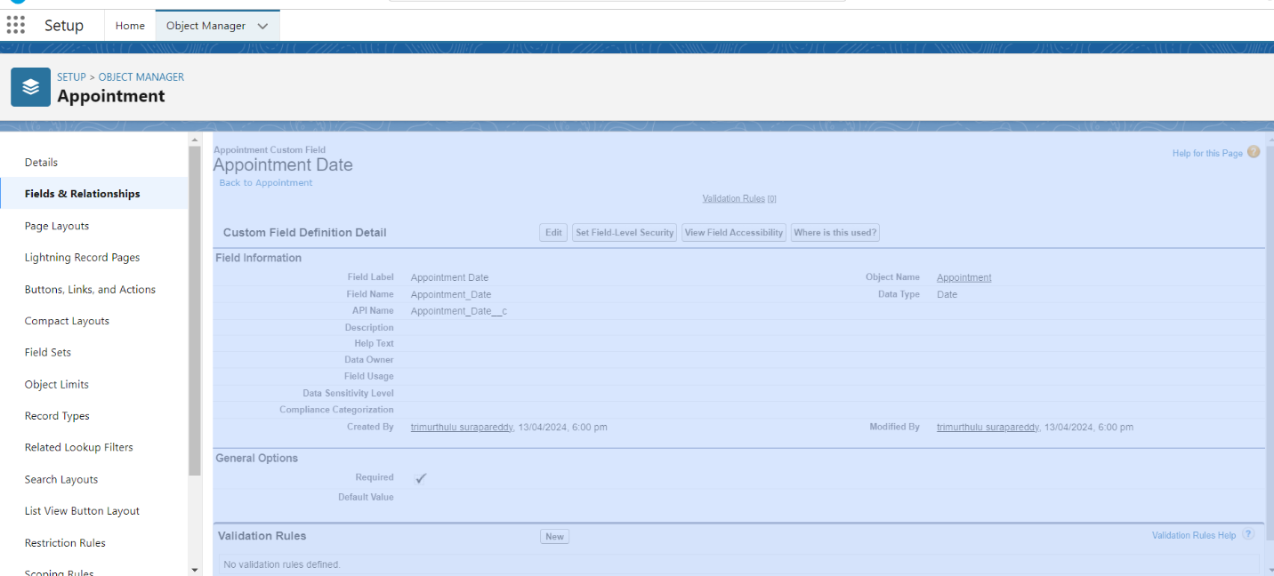

**TSK180069**

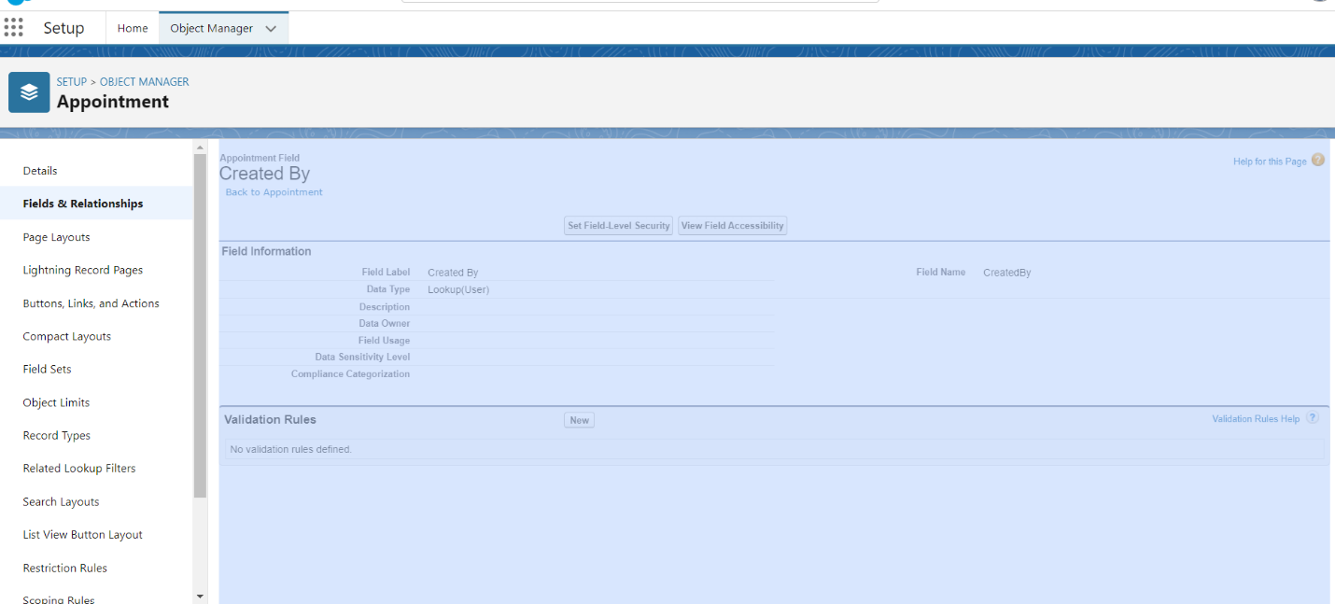

**TSK-180070**

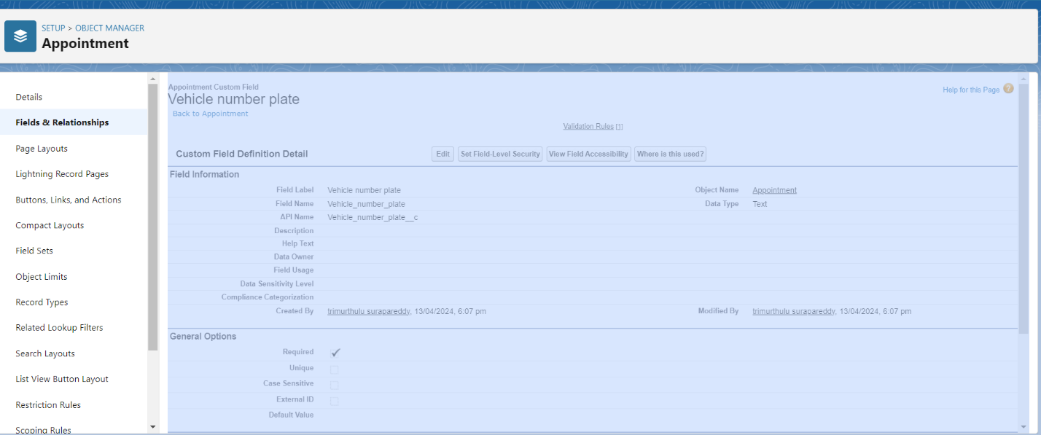

**TSK-180071**

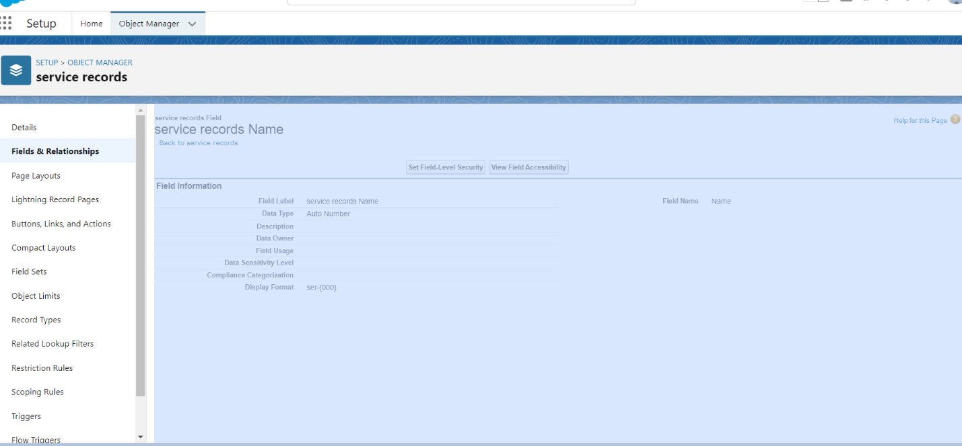

**TSK-180072**

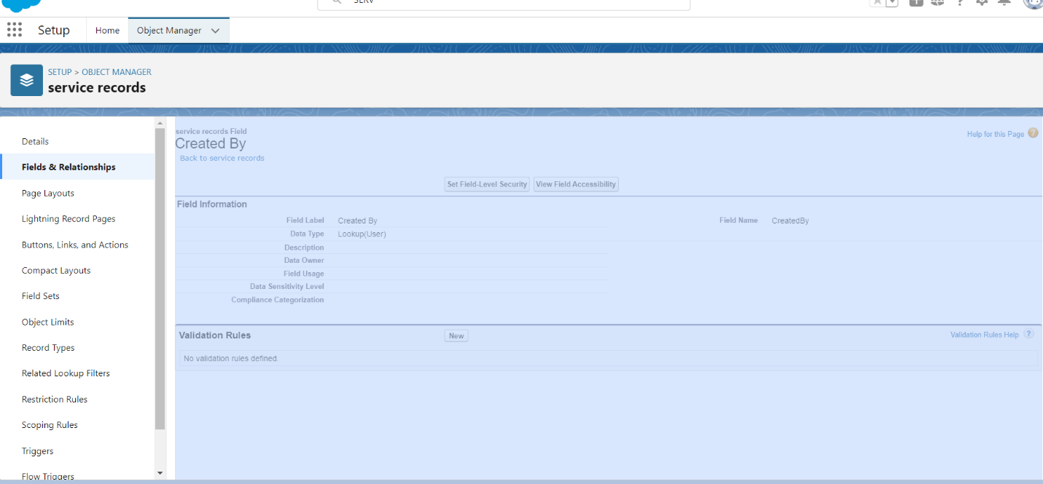

**TSK-180073**

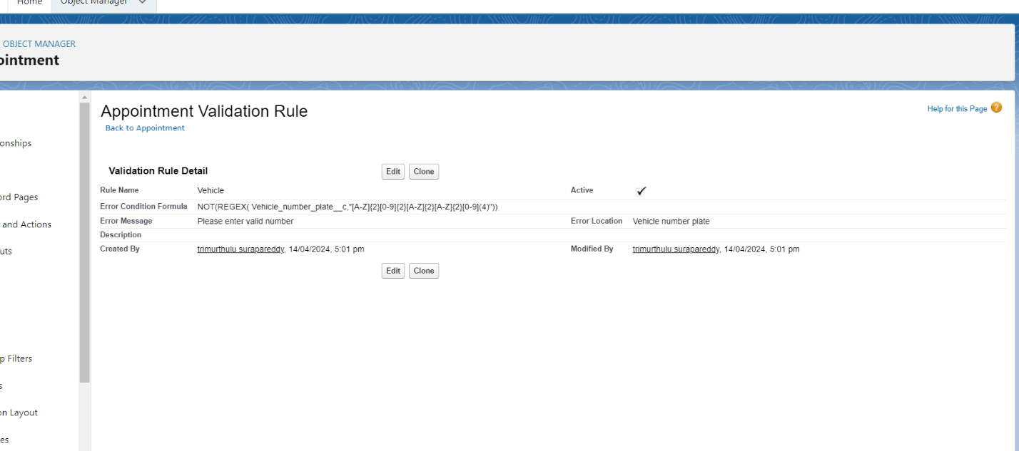

**TSK-180074**

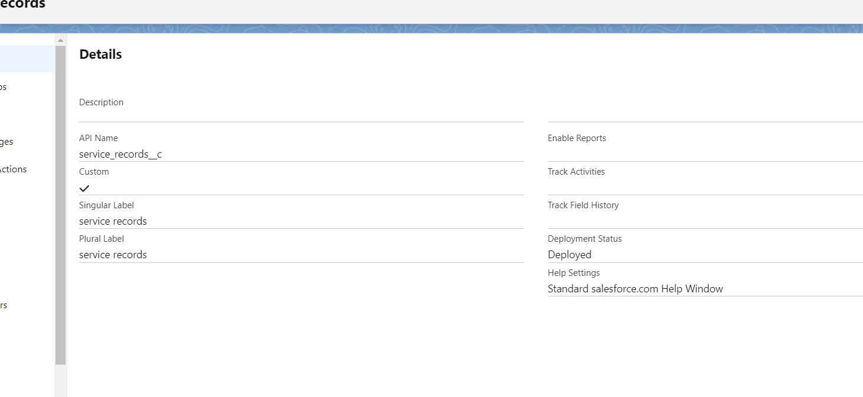

**TSK-180075**

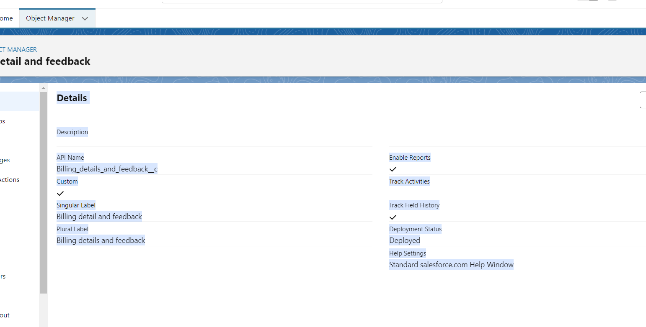

**TSK-180076**

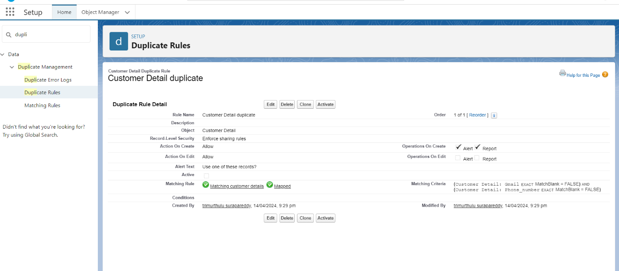

**TSK-180077**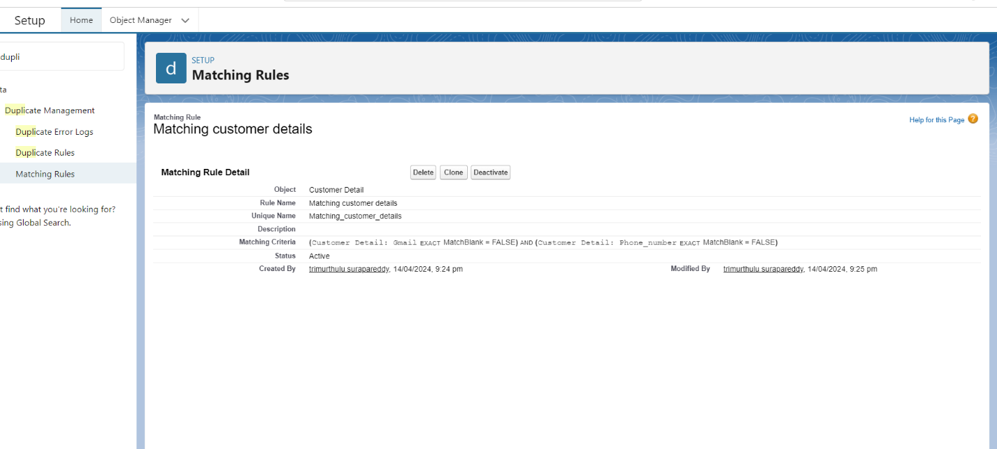

**TSK-180078**

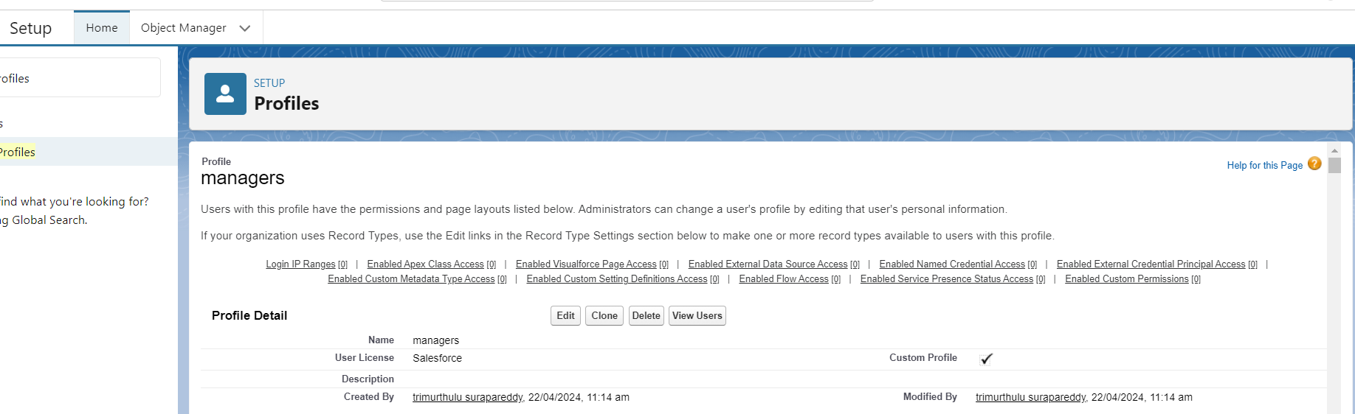

**TSK-180079**

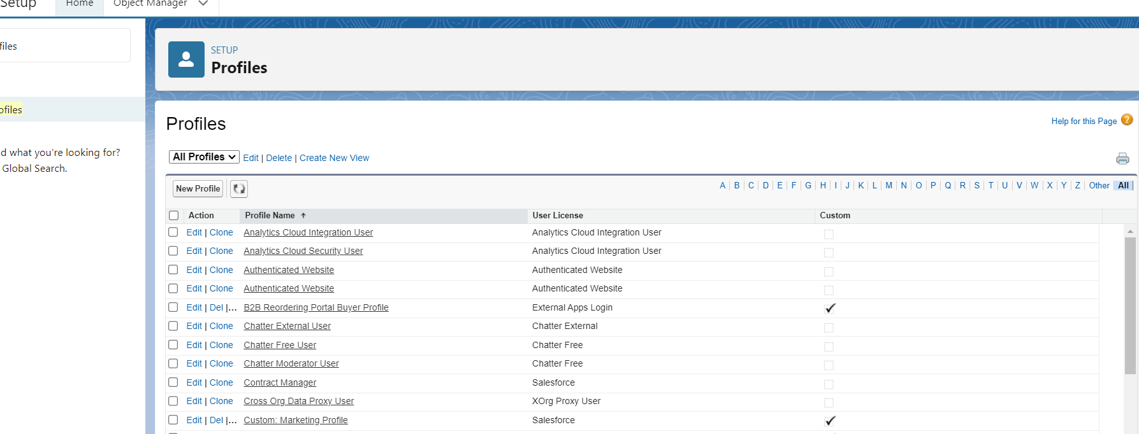

**TSK-180080**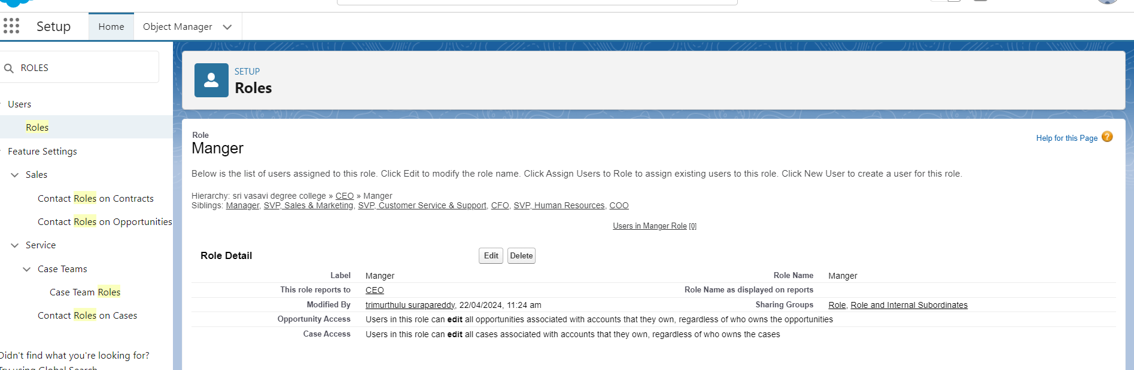

**TSK-180081**

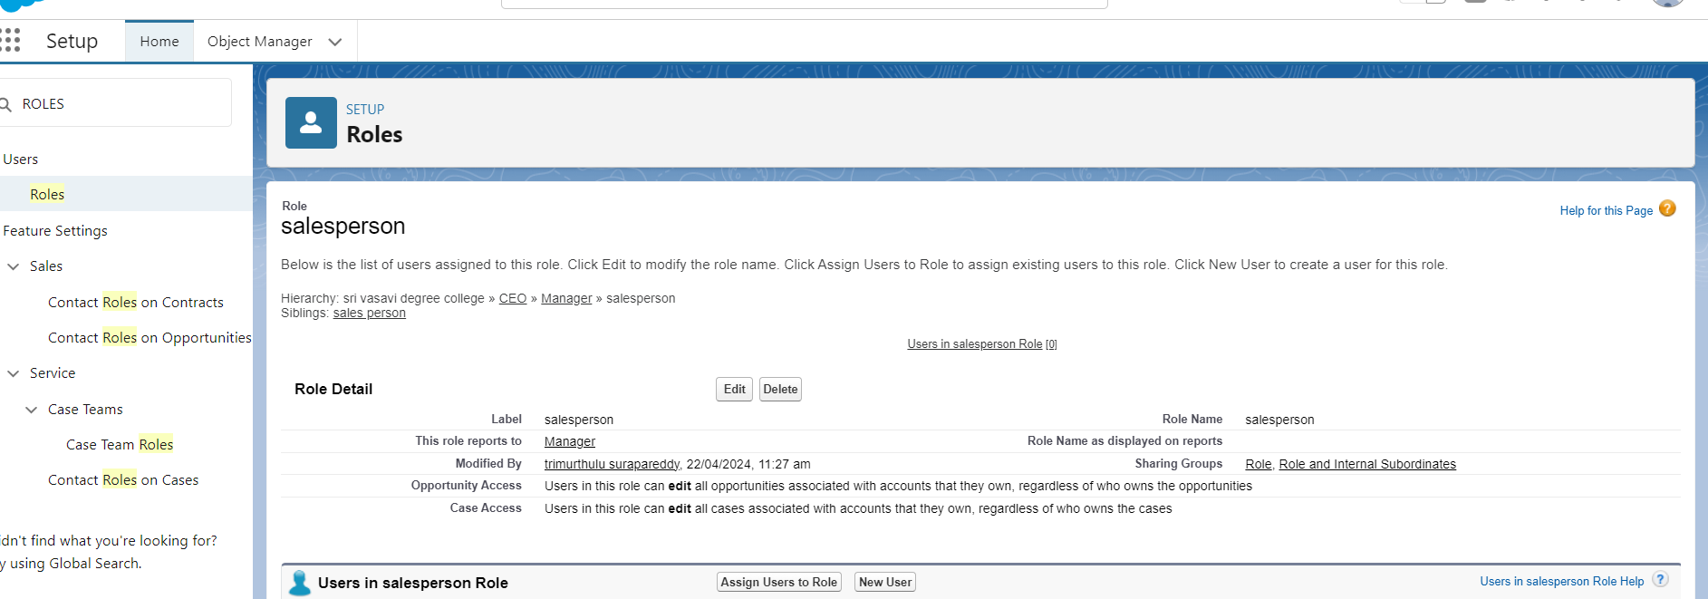

**TSK-180082**

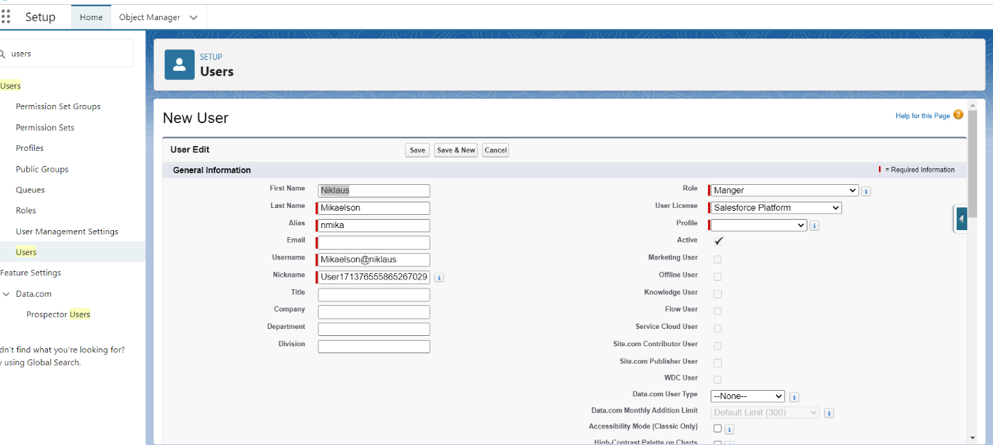

**TSK-180083**

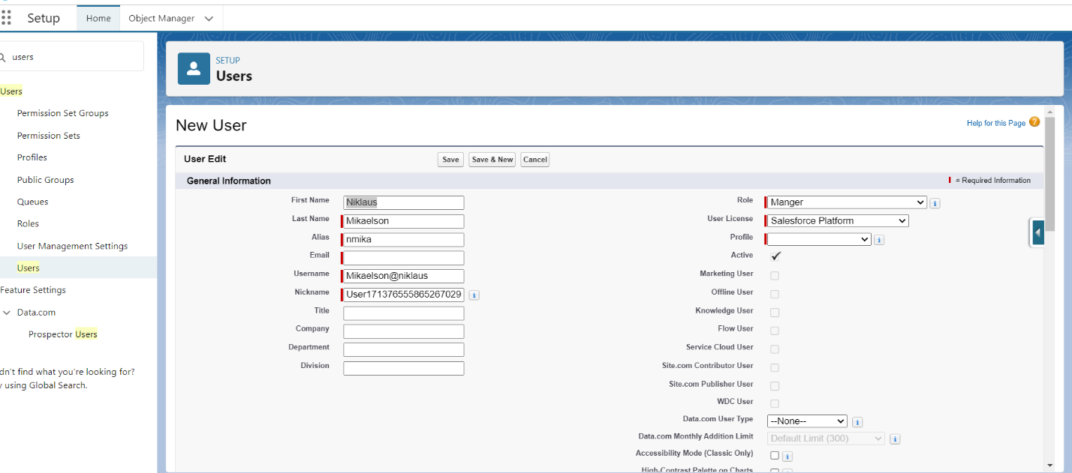

**TSK-180084**

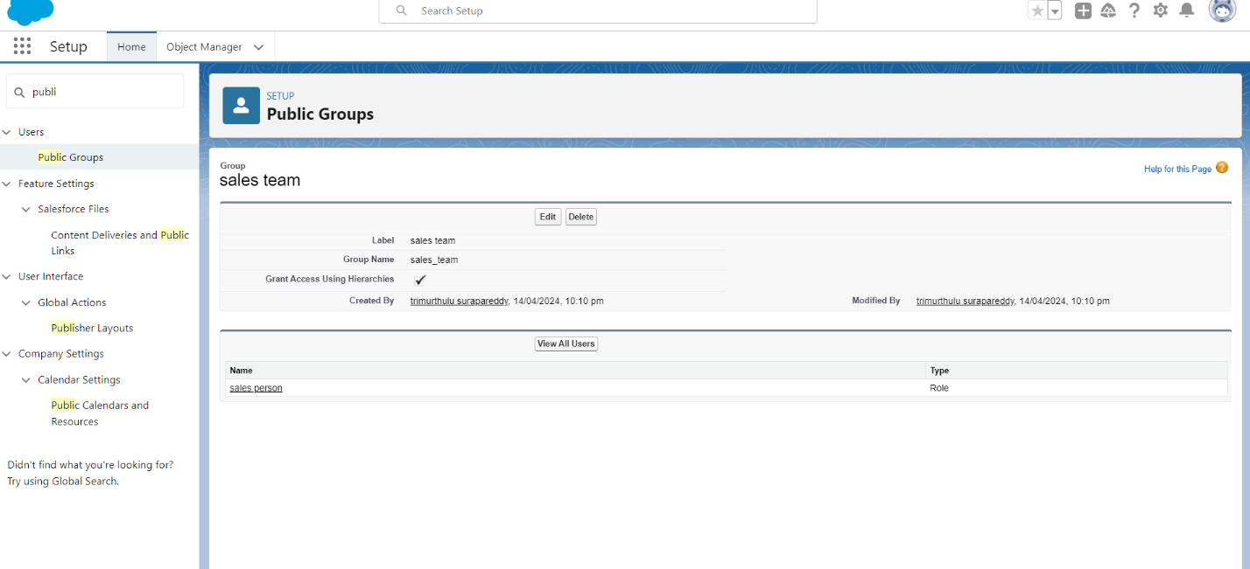

**TSK-180085**

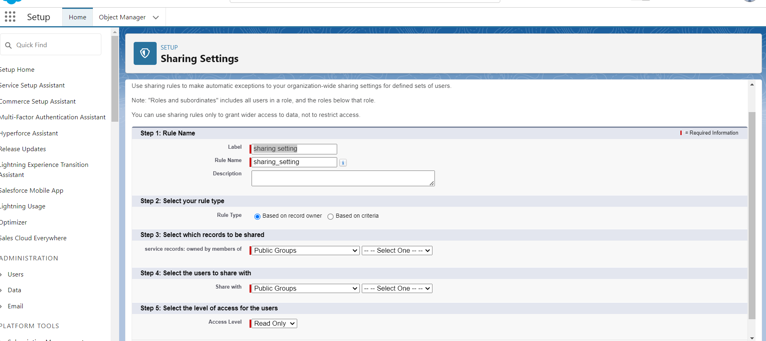

**TSK-180086**

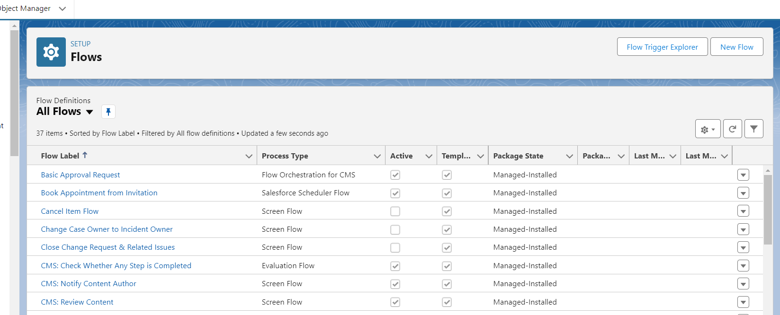

**TSK-180087**

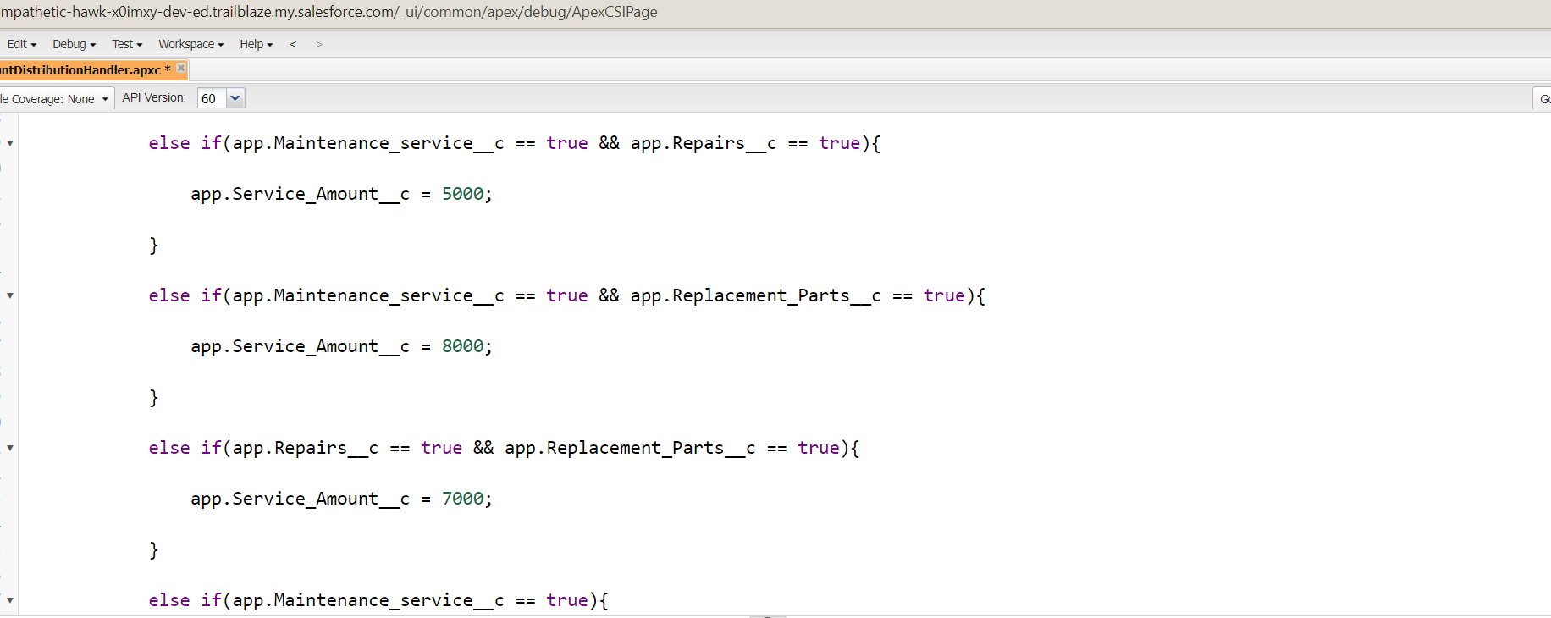

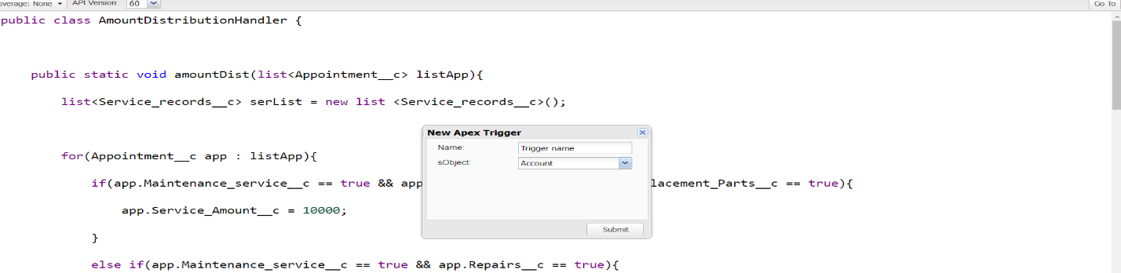

**TSK-180088**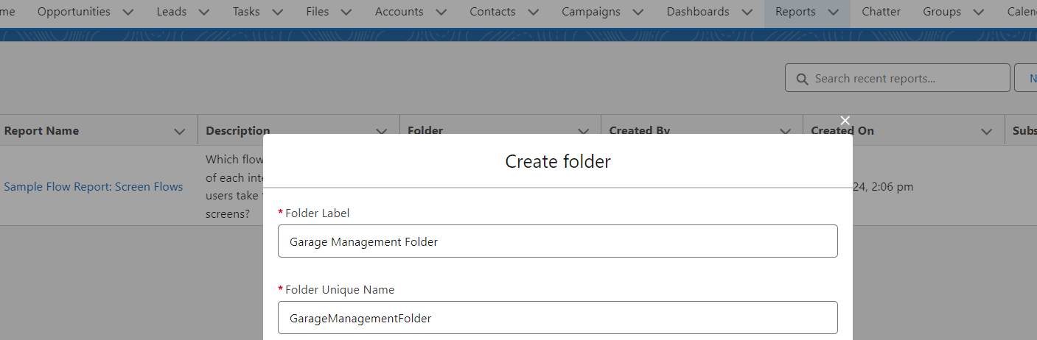

**TSK-180089**

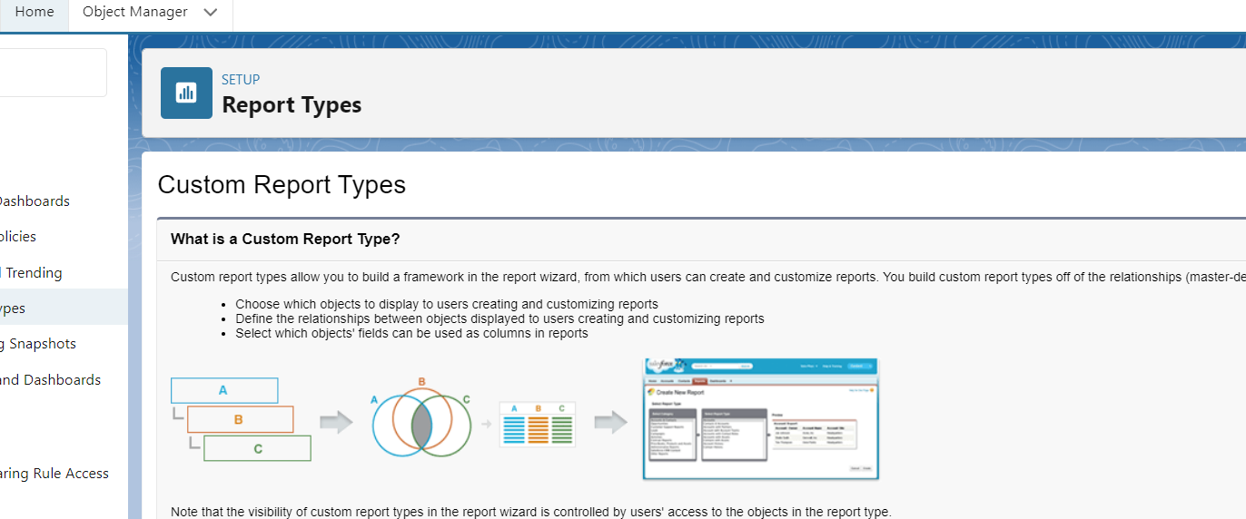

**TSK-180090**

